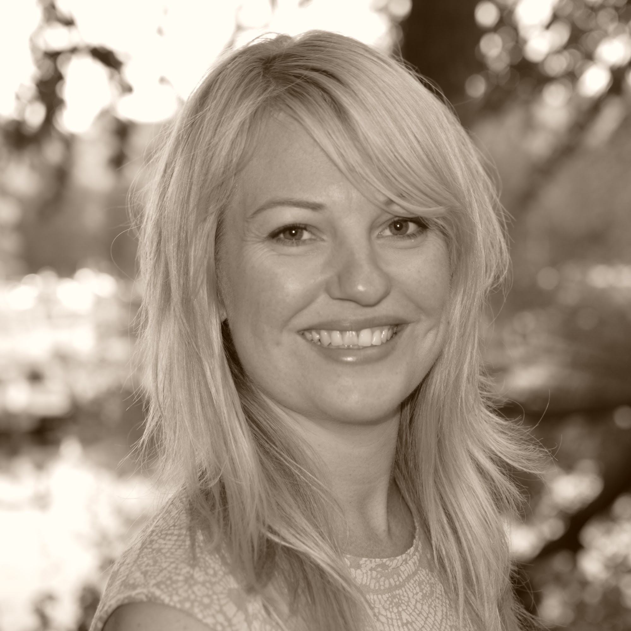
CV
Catrin Söderdahl
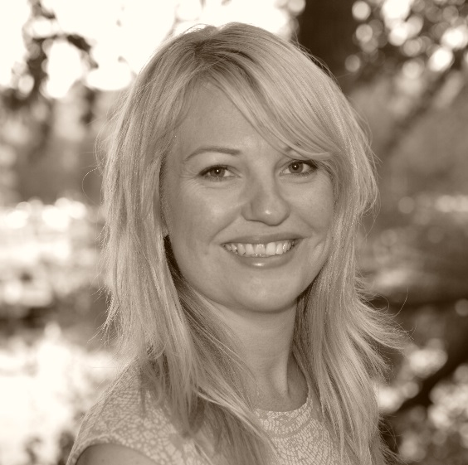

ID number: 790707
Mobile: + 46 722 36 26 73
Mail: catrin@absolutelygorgeous.com
Nationality: Swedish

- Is fluent in Swedish, English and Spanish
- Loves challenges
- Has many years of international experience, has worked in Sweden, Southern Spain, Barcelona and Australia
- Have been a mentor for Cherie Blair Fondation for women (www.cherieblairfoundation.org/mentoring-draft )
- Positive and cooperative
WORKING EXPERIENCE:

- 2007-present Business owner at Absolutely Gorgeous BCN in Stockholm and Barcelona, freelancing as a hair and makeup artist for weddings and other events. (http://absolutelygorgeousbcn.com/)
- 1st February 2013-present working when availeble as a stylist at Hair Stars, Stockholm. (www.hairstars.com)
- 2011-2013 Chair rental at salon " Pinups and Pimps " Hair salon in Barcelona.
- 2006-2011 Employed Hairdresser/Makeup Artist, Anthony Llobet hair salon, Barcelona. (www.anthonyllobet.com)
- 2004-2005 Employed hairdresser,Levon Hair Design, Sydney.
- 2001-2003 Employed hairdresser, salon Margaretha, Torrevieja.
- 1999-2001 Chair rental at Hair Stars, hair/makeup salon, Stockholm
EDUCATION:
- 2007 Make up training, Stick Art Studio, Barcelona
- 1996-1999 Hairdressing acadamy, Nacka Gymnasium

